1.

2.

3.

4.

5.

6.

7.

8.

9.

10.

11.

12.

13.

14.

15.

16.

17.

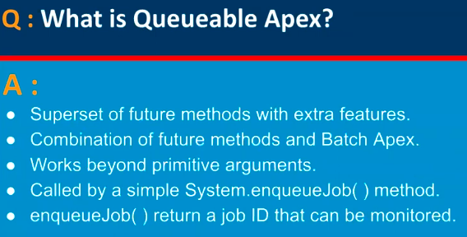

18.

19.

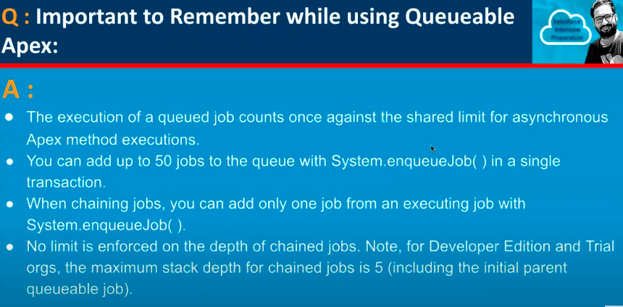

20.

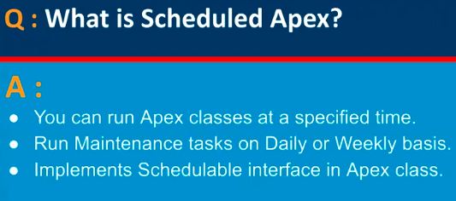

21.

22.

23.

